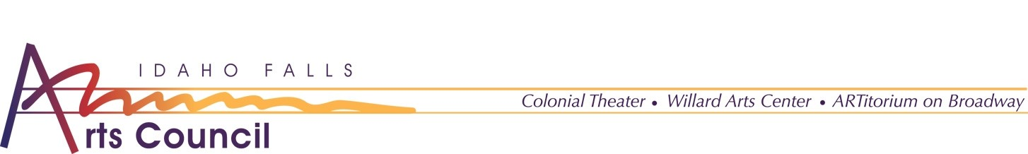
PRESS RELEASE
Catapult
October 28th 2021

The Idaho Falls Arts Council is pleased to announce another 2021-2022 Mainstage Theater Show, Catapult. Catapult Entertainment is a shadow-illusion company. They have been on Americas Got Talent and have been wowing audiences of all ages ever since.

“We are excited to host Catapult”, said Executive Director Brandi Newton. “They give the community a chance to see something truly unique that is appropriate for all ages.”

Colonial Theater 7:30pm
Tickets: $35|$30|$20

Out of an abundance of respect for our community's health care workers, masks are required when social distance cannot be maintained. Masks are required to enter the building and when in the Colonial Theater. Masks may be removed when consuming refreshments.

The Idaho Falls Arts Council is a private nonprofit organization which owns and operates: ARTitorium on Broadway, The Colonial Theater, and the Willard Arts Center. The mission of IFAC, in cooperation with other arts organizations, is to educate our community and enrich its quality of life by promoting, advocating, and presenting a broad spectrum of visual and performing arts in eastern Idaho.
For questions regarding information contained in this release, please contact Jordyn Eckman, Marketing Assistant, or at jeckman@idahofallsarts.org or at 208-522-0471

